FOOD RECIPE

SATORU FOUNDATION

VERSI 1.1

Oleh:

1. Ridhuan Rangga Kusuma (1152200025)
2. Jonathan Natanael Zefanya (1152200024)
3. Lutfi Ekaprima Jannata (1152200006)
4. Daffa Nur Fakhri (1152200027)

Program Studi Teknik Informatika

Institut Teknologi indonesia

13 Juni 2024

1.Reset_password.dart

1. Code Program

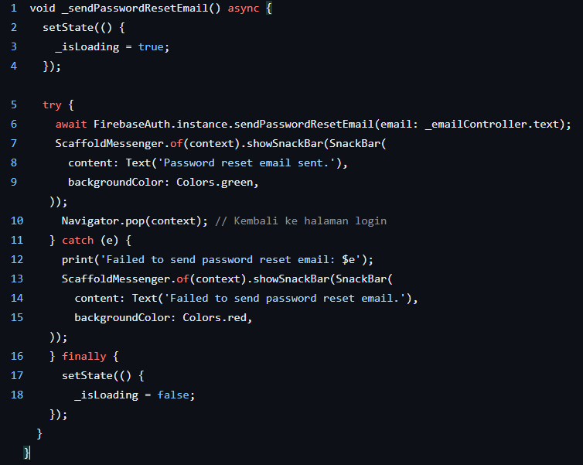

1. Graph

Try = True -> success

Try = False/Error -> catch

1. Path Pengujian
2. 1 - 2,3,4 - 5 - 6 - 7,8,9,10 - 16,17,18
3. 1 - 2,3,4 - 5 - 6 - 11,12,13,14,15 - 16,17,18

1. cyclomatic complexity (V(G)
2. The flow graph has Two regions.

1. region struktur program

2. region try

1. V(G) = 6 edges – 6 nodes + 2 = 2
2. Start code
3. Set = true
4. Try code
5. Success output (true)
6. Failed output (catch)
7. Finally,set = false
8. V(G) = 1 predicate nodes + 1 = 2
9. Try code + 1

2. loginform.dart

1. Code Program

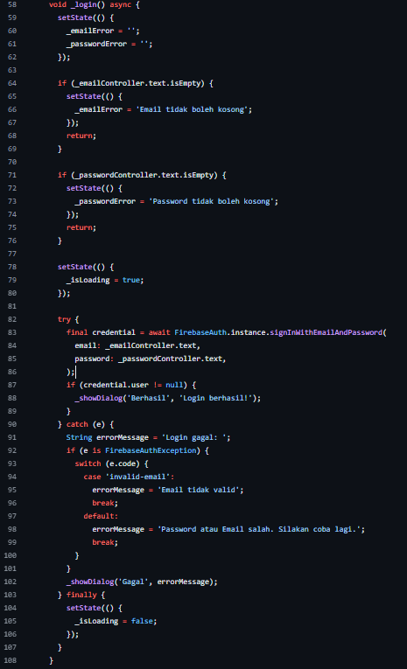

2. Graph

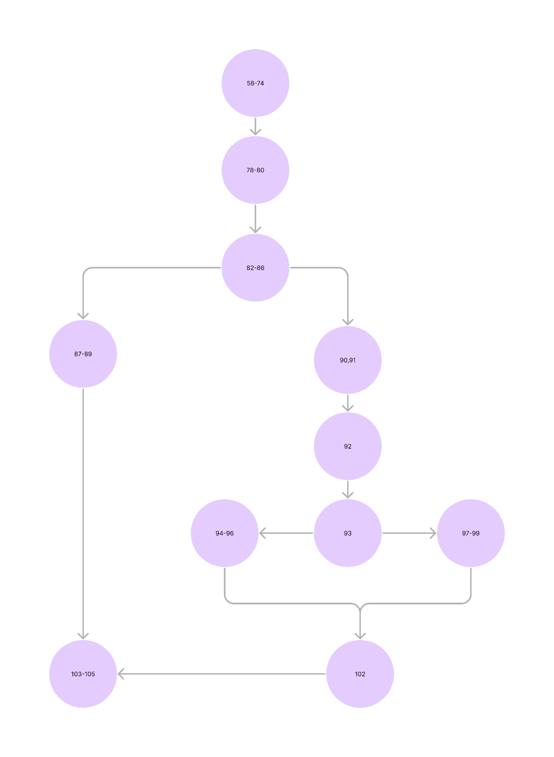

3. Path Pengujian

1. 56,57,58,59,60,61,62,63,64,65,66,67,68,69,70,71,72,72,74 – 78,79,80 – 82,83,84,85,86 – 87,88,89 – 103,104,105

2. 56,57,58,59,60,61,62,63,64,65,66,67,68,69,70,71,72,72,74 – 78,79,80 – 82,83,84,85,86 – 90,91 – 92 – 93 – 94,95,96 – 102 – 103,104,105

3. 56,57,58,59,60,61,62,63,64,65,66,67,68,69,70,71,72,72,74 – 78,79,80 – 82,83,84,85,86 – 90,91 – 92 – 93 – 97,98,99 – 102 – 103,104,105

1. cyclomatic complexity (V(G)
2. The flow graph has Three regions.

1. region struktur program

2. region try

3. region if,else statment

1. V(G) = 12 edges – 11 nodes + 2 = 3
2. Start code
3. Set = true
4. Try code
5. Success output (true)
6. Failed output (catch)
7. Finally,set = false
8. V(G) = 2 predicate nodes + 1 = 2
9. If,Else Statment + Try code + 1

3. daftar.dart

1. Code program

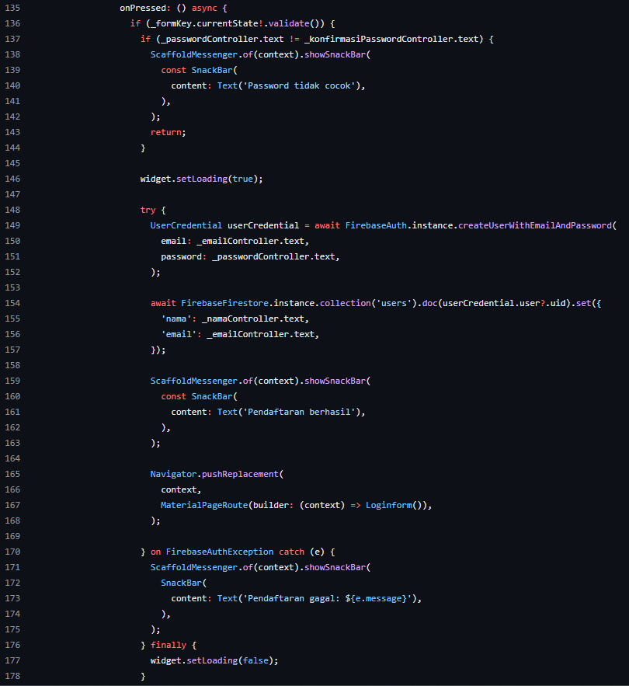

2. Graph

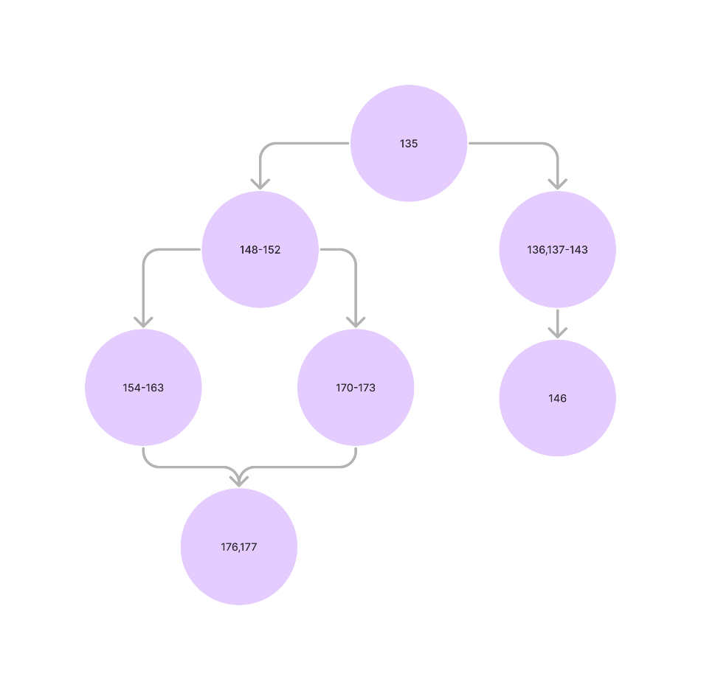

3. Path pengujian

1. 135 – 136,137,138,139,140,141,142,143 – 146

2. 135 – 148,149,150,151,152 – 154,155,156,157,158,159,160,161,162,163 – 176,177

3. 135 – 148,149,150,151,152 – 170,171,173 – 176,177

1. cyclomatic complexity (V(G)
2. The flow graph has Two regions.

1. region struktur program

2. region try

1. V(G) = 7 edges – 7 nodes + 2 = 2

1. Start code

2. Set = true

3. Try code

4. Success output (true)

5. Failed output (catch)

6. Finally,set = false

1. V(G) = 1 predicate nodes + 1 = 2
2. Try code + 1